IP & MAC ADDRESS LAB
Topology Diagram

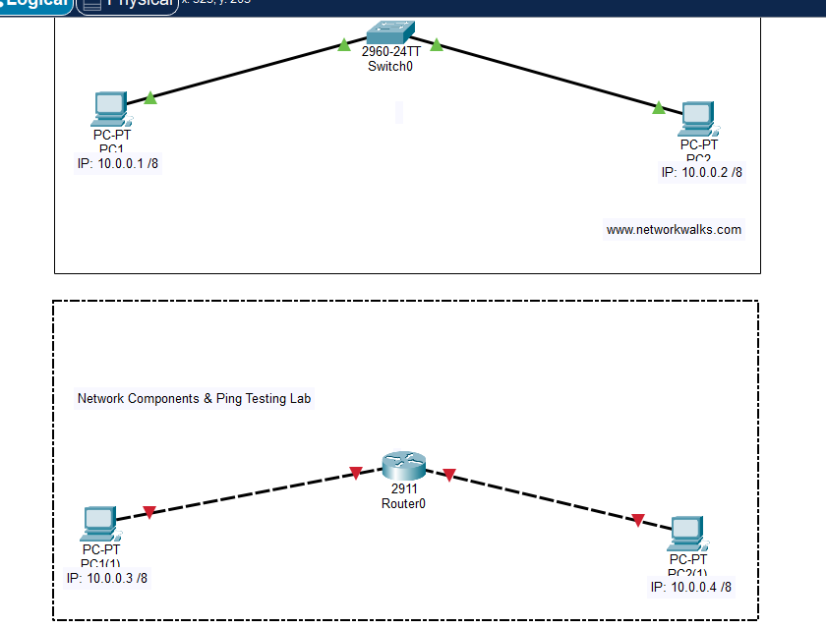
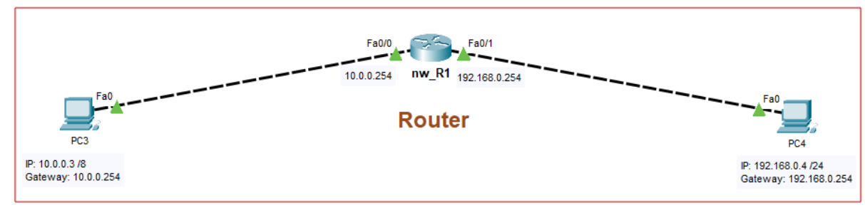

Task

- Enable all relevant interfaces on Switch & Router (Fa0/0, Fa0/1, Fa0/2)
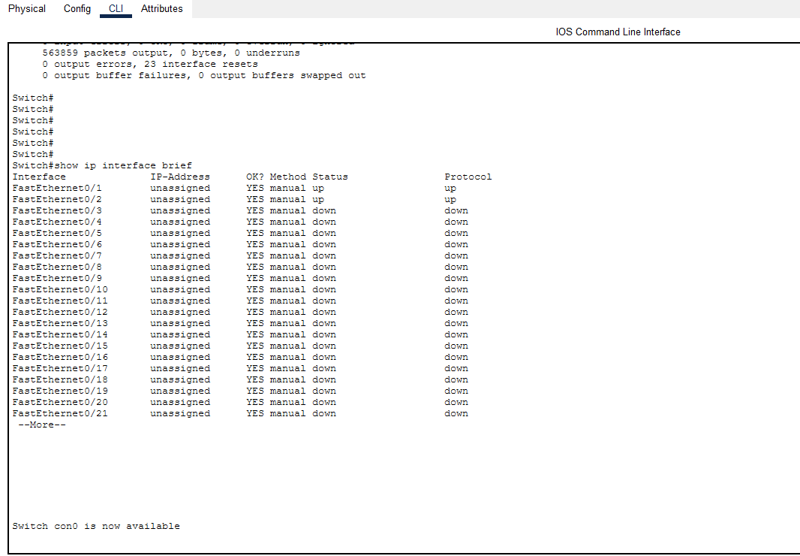

- Assign IP addresses to PC's & Router interfaces (IP's are shown in topology)

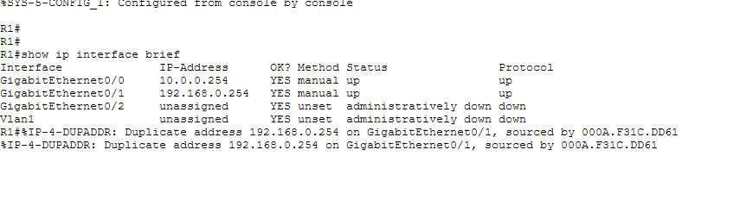
- Test the connectivity between PC1-to-PC2 and PC3-to-PC4 using Ping command

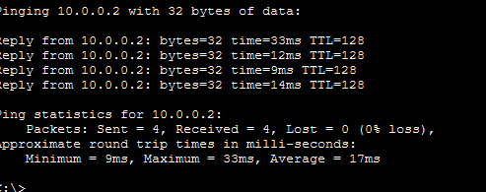

- Find what is the MAC address of switch port Fa0/1 using commands?

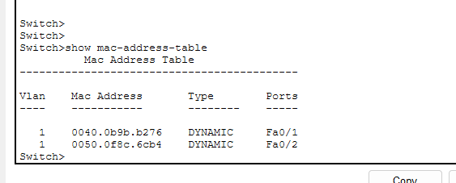
- Find how many MAC entries are there in the Switch's MAC Table?
- Find how many routes are there in the Routing table of nw_R1?


